**CHAPTER - 1**

# INTRODUCTION

**1.INTRODUCTION**

## The Indian Premier League (IPL) is a popular cricket league in India. It started in 2008 and features teams from different cities. The IPL is known for its exciting matches and has players from all over the world. The league has changed the way cricket is played and watched, making it more entertaining and engaging for fans.

In the context of modern sports analytics, cricket presents a fascinating challenge and opportunity due to its intricate gameplay, diverse player skills, and the dynamic nature of match conditions. The Indian Premier League (IPL), known for its high-paced T20 format and star-studded lineups, serves as a perfect testing ground for applying cutting-edge machine learning techniques.

Machine learning in cricket analytics involves the use of algorithms to analyse vast amounts of data, ranging from player statistics and match results to environmental factors like weather and pitch conditions. These algorithms can uncover hidden patterns, predict match outcomes with increasing accuracy, and provide actionable insights for teams, coaches, and analysts.

The IPL Winning predictor project aims to leverage these capabilities to not only forecast match results but also to enhance strategic decision-making in real-time. By integrating historical performance data, real-time metrics, and predictive models, the project seeks to offer comprehensive insights into player form, team dynamics, and match conditions. This holistic approach not only enhances the competitiveness of the sport but also enriches the fan experience by providing deeper insights into the game.

Cricket, especially T20 cricket like the IPL, can be unpredictable. Many factors like player performance, team strategy, pitch conditions, and weather can affect the outcome of a match. Accurate predictions are important for:

**Teams and Coaches**: To plan strategies and improve performance.

**Fans**: To enjoy the game more by knowing what might happen.

**Betting and Fantasy Sports**: To provide better insights for users.

**Media**: To create interesting content and analysis.

The aim of this project is to develop a tool that can predict the results of IPL matches using machine learning techniques. Machine learning allows us to analyse large amounts of data and identify patterns that can help in making accurate predictions. To achieve this, we will:

**Collect Data**: Gather historical data on IPL matches, including player statistics, team performance, pitch conditions, and weather reports.

**Preprocess Data**: Clean and organize the data to make it suitable for analysis.

**Feature Selection**: Identify the most important factors (features) that affect match outcomes.

**Model Development**: Train various machine learning models using the collected data to predict match outcomes.

**Evaluation**: Test the models to see how well they perform and choose the best one.

**Deployment**: Create a user-friendly tool that can be used to predict future IPL match outcomes.

**CHAPTER - 2**

### LITERATURE SURVEY

Cricket prediction has been a topic of interest for many researchers and analysts. In the past, simpler methods like statistical analysis were used to predict the outcomes of matches. For example, analysts would look at batting averages, bowling figures, and team rankings to make educated guesses about who might win a game. With the advent of more advanced data analysis techniques, more complex models have been developed. Researchers have used historical match data to create algorithms that predict outcomes based on various factors, such as player performance and match conditions. Some studies have focused on specific aspects of cricket, like predicting the number of runs a player might score or the probability of a team winning based on the match situation. Overall, these efforts have shown that while predicting cricket matches is challenging, it is possible to make reasonably accurate predictions using data analysis.

The literature survey on cricket predictions using machine learning reveals a growing interest in applying data-driven approaches to enhance the accuracy of match outcome forecasts. Previous studies have extensively explored various machine learning techniques, including regression models, decision trees, support vector machines (SVM), and neural networks, to analyse historical cricket data. These models leverage player statistics, team performance metrics, pitch conditions, weather data, and other factors to predict match results.

Researchers have highlighted the effectiveness of ensemble methods, such as random forests and gradient boosting, in improving prediction robustness by combining multiple models. Studies often compare the predictive performances of different algorithms, evaluating metrics like accuracy, precision, recall, and F1 score to assess model efficiency. Moreover, advancements in natural language processing (NLP) techniques have facilitated sentiment analysis of cricket match commentaries and social media data to capture public sentiment's impact on game outcomes.

Challenges identified in existing literature include the complexity of cricket as a sport, the volatility of player performances, and the influence of external factors like weather and pitch conditions. Researchers emphasize the importance of feature engineering and data preprocessing techniques to mitigate noise and enhance model reliability. Furthermore, there is ongoing exploration into incorporating real-time data streams and advanced analytics to adapt predictions dynamically during matches, reflecting the evolving nature of sports analytics and machine learning applications in cricket prediction.

### ****Real-Time Data and Advanced Analytics****

By continuously updating models with live data, analysts can provide dynamic predictions that reflect the current state of the match.

**Research Studies**

Several research studies have been conducted in the field of IPL match win prediction. These studies often explore new techniques, feature combinations, and models to improve prediction accuracy. Some studies also focus on specific aspects like home ground advantage, player injuries, and team dynamics.

It's worth noting that IPL match win prediction is a challenging task due to the inherent unpredictability of cricket and the dynamic nature of the game. While predictive models can provide insights and probabilities, they may not always be accurate. It's important to consider multiple factors and use predictions as a reference rather than a definitive outcome.

Ahmad et al, predicted the emerging players from batsman as well as from the bowlers using machine learning techniques. Song et al predicted estimation of the location of a moving ball based on the value of the cricket sensor network. Roy et al predicted ranking system which is based on the social network factors and their evaluation in the form of composite distributed framework using Hadoop framework and MapReduce programming model is used for processing the data. Priyanka et al, predicted the outcome of IPL-2020 based on the 2008-2019 IPL datasets using Data Mining Algorithms with an accuracy of 82.73%.

Kansal et al predicted player evaluation in IPL based on the 2008-2019 datasets using Data Mining Technique. Data mining algorithms are used which gives evaluation using player statistics assessing a player's performance and determining his base price. They predicted about how to select a player in the IPL, based on every player’s performance history using algorithms like decision tree, Naïve Bayes and Multilayer perceptron (MLP). MLP outperforms better than other algorithms. Agrawal et al, used Support Vector Machine (SVM), C Tree, and Naïve Bayes classifiers with accuracies of 95.96%, 97.97% and 98.98% respectively, to predict the probability of the winner of the matches. Barot et a., predicted the match outcome based on the toss and venue.

Kaluarachchi et al, predicted match outcome using home ground, time of the match, match type, winning the toss and then batting first by using Naïve Bayes classifier. Passi et al, predicted the performance of players based on the runs and the number of wickets. Both the type of problems is treated as classification problems where the list of runs, and list of wickets are classified in different ranges based on machine learning algorithms. The Random Forest algorithm outperforms better than other algorithms. Nigel Rodrigues et al, predicted the value of the traits of the batsmen and the bowlers in the current match. This would help in selecting the players for the upcoming matches by using past performances of a player against a specific opposition team by using Multiple Random Forest Regression.

Wright, predicted the possible fixture for a cricket match based on the various venue, teams, number of holidays between each match in a fair and efficient manner. A metaheuristic procedure is used to progress from the basic solution to a complex final solution by a technique, Sub cost-Guided Simulated Annealing (SGSA). Maduranga et al, predicted the outcome of any cricket match by using data mining algorithms and provided solutions for the approach used by other authors. Shetty et al, predicted the capabilities of each player depending on various factors like the ground, pitch type, opposition team and several others by using machine learning techniques. The model gave an accuracy of 76%, 67%, and 96% for batsmen, bowlers, and all-rounders respectively by using Random Forest Algorithm. This model helped them to select the best players of the game and predict outcomes of the match.

The literature on IPL winning predictions and player performance analysis showcases various machine learning and data mining techniques. Ahmad et al. focused on predicting emerging players, while Priyanka et al. predicted IPL-2020 outcomes with 82.73% accuracy using historical data. Kansal et al. evaluated player performance using decision trees, Naïve Bayes, and MLP, finding MLP most effective. Agrawal et al. achieved high accuracy in match winner predictions using SVM, C Tree, and Naïve Bayes. Nigel Rodrigues et al. used Multiple Random Forest Regression for player selection, and Shetty et al. assessed player capabilities with Random Forest, achieving up to 96% accuracy.

**CHAPTER - 3**

# METHODOLOGY

### 3. Data Collection and Preprocessing

#### 3.1 Data Sources

To build an accurate IPL cricket predictor, we need to gather data from various sources. The quality and comprehensiveness of the data significantly influence the accuracy of our predictions. Here are the main types of data we will collect:

##### 3.1.1 Player Statistics

Player statistics include data about individual player performances. This can cover various aspects such as batting averages, bowling figures, strike rates, and fielding records. Historical performance data helps in understanding how players have performed over different seasons and in different conditions. For example, knowing how a batsman scores against different bowlers or how a bowler fares on different pitches can provide valuable insights for predictions.

##### 3.1.2 Team Performance

Team performance data includes overall team statistics, such as win/loss records, average scores, and performances in different match conditions. This data helps in understanding how teams perform as a unit. Factors like team composition, captaincy, and historical performance against specific opponents are crucial. For instance, a team's track record in chasing targets versus setting targets can be a key factor in predicting match outcomes.

##### 3.1.3 Weather Conditions

Weather conditions can significantly impact cricket matches. Information on temperature, humidity, rain forecasts, and wind speeds are essential as they can affect pitch conditions and player performance. For example, a damp pitch might favour bowlers, while clear, sunny weather might be better for batsmen. Including weather data in our analysis helps in making more informed predictions.

#### 3.2 Data Cleaning

Once we have collected the raw data, the next step is data cleaning. Raw data often contains errors, missing values, or inconsistencies that need to be addressed to ensure accurate analysis. Data cleaning involves:

**Removing duplicates**: Ensuring that each data point is unique.

**Handling missing values**: Filling in gaps with appropriate values or removing incomplete records.

**Correcting errors**: Fixing any inaccuracies in the data, such as incorrect player names or team statistics.

**Standardizing formats**: Ensuring that all data is in a consistent format, which is crucial for accurate analysis.

Cleaning the data ensures that it is reliable and ready for further processing.

#### 3.3 Data Transformation

After cleaning, the data needs to be transformed into a suitable format for machine learning models. Data transformation involves several steps:

**Normalization**: Scaling numerical data to a standard range (e.g., 0 to 1) to ensure that all features contribute equally to the model.

**Encoding categorical variables**: Converting categorical data (like player names, teams) into numerical values using techniques such as one-hot encoding or label encoding.

**Feature extraction**: Creating new features from existing data that might be more relevant for prediction. For example, calculating a player's recent form based on their last few matches.

**Aggregation**: Summarizing data to capture broader trends, such as average team scores over a season.

These steps help in preparing the data for effective training of machine learning models.

**Fig:Steps in Model Development**

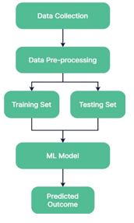

**3.4 Tools and Libraries Used**

Several tools and libraries facilitate data collection, cleaning, and transformation. Here are some commonly used ones:

**Python**: A versatile programming language widely used in data science.

**Pandas**: A Python library for data manipulation and analysis. It is useful for handling data frames and performing data cleaning and transformation.

**NumPy**: A library for numerical computations in Python. It is useful for performing operations on arrays and matrices.

**Scikit-learn**: A machine learning library in Python that provides tools for data preprocessing, model training, and evaluation.

**Jupyter Notebook**: An interactive computing environment that allows you to write and execute code in real time, making it easier to explore and visualize data.

Using these tools and libraries helps streamline the data preprocessing workflow and ensures that the data is prepared efficiently and effectively for model training.

**CHAPTER – 4**

## SYSTEM DESIGN AND IMPLEMENTATION

#### 4.1 Feature Selection Techniques

Feature selection is a critical step in developing an IPL cricket predictor using machine learning. It involves choosing the most relevant features from the dataset to improve prediction accuracy and reduce computational complexity.

**Techniques Used:**

**Correlation Analysis**: This method examines the relationship between each feature and the target variable (e.g., match outcome). Features with high correlation are likely to have a significant impact on predictions.

**Feature Importance**: Algorithms like Decision Trees and Random Forests can quantify the importance of each feature in predicting outcomes. Features with higher importance scores are selected for model training.

**Recursive Feature Elimination (RFE)**: RFE works by recursively removing features and building a model to evaluate their contribution to prediction accuracy. It selects the optimal subset of features that maximize model performance.

**Domain Knowledge**: Leveraging expertise in cricket and understanding which features are most influential in determining match outcomes. This approach ensures that relevant aspects like player form, team strategy, and match conditions are adequately represented.

**Programming Language**

**Python:**

**Versatility:** Python is chosen due to its simplicity and readability, making it accessible for developers at all levels.

**Extensive Libraries**: It boasts a wide array of libraries tailored for machine learning, data analysis, and image processing.

#### 4.2 Model Selection

Selecting an appropriate machine learning model is crucial for accurate predictions in IPL cricket. Different models have varying strengths and are suitable for different types of data and prediction tasks.

**Models Considered:**

**Logistic Regression**: Logistic regression is a statistical model that can be used for binary classification problems, such as predicting the winner of an IPL match. It Choose relevant features (e.g., team performance stats, player averages, pitch conditions). Convert categorical variables into numerical format if needed.

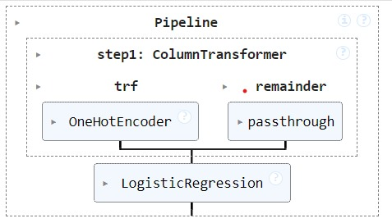

**Fig: Logistic Regression**

**Random Forest**: Ensembles of decision trees that improve prediction accuracy and handle complex relationships in data.

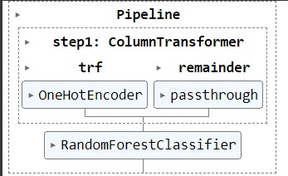

**Fig: Random Forest Classifier**

#### 4.3 Training Process

The training process involves feeding the selected features and corresponding outcomes into the chosen machine learning model. During training, the model learns patterns and relationships from the data to make predictions on new, unseen data.

**Steps in Training:**

**Data Splitting**: Dividing the dataset into training and testing sets to evaluate model performance.

**Model Initialization**: Initializing the selected model with appropriate parameters and settings.

**Model Fitting**: Training the model on the training dataset to learn patterns and associations between features and outcomes.

**Evaluation**: Assessing the model's performance using evaluation metrics like accuracy, precision, recall, and F1-score.

#### 4.4 Hyperparameter Tuning

Hyperparameters are parameters that are not directly learned during training but affect model performance and learning speed. Tuning these hyperparameters optimizes the model's performance and generalization capability.

**Techniques for Hyperparameter Tuning:**

**Grid Search**: Exhaustively searches through a manually specified subset of hyperparameters to find the best combination based on cross-validation performance.

**Random Search**: Randomly selects combinations of hyperparameters to optimize model performance. It is computationally efficient compared to grid search.

**Bayesian Optimization**: Uses probabilistic models to predict the next set of hyperparameters based on past performance, reducing the number of evaluations needed.

**Data Manipulation**

#### NumPy:

#### Array Operations: Provides support for large multi-dimensional arrays and matrices, along with a collection of mathematical functions to operate on these arrays.

#### Efficiency: NumPy is highly efficient, making it suitable for handling large datasets and performing complex computations quickly.

#### Pandas:

#### Data Frames: Offers data structures like Data Frames, which are ideal for handling and manipulating structured data.

#### CSV Handling: Facilitates the loading, manipulation, and analysis of data from CSV files, such as the train.csv file containing image labels and metadata.

#### Matplotlib:

#### Image Visualization: Used to display retinal images, allowing for visual inspection and verification of preprocessing steps.

#### Performance Metrics: Essential for plotting training and validation metrics such as loss and accuracy over epochs, providing insights into the model's performance.

#### Results Evaluation: Helps in visualizing the classification results, including confusion matrices and ROC curves, which are critical for assessing model efficiency.

**Chapter 5**

**Model Evaluation and Prediction**

#### 5.1 Evaluation Metrics

Evaluation metrics are essential in assessing the performance of our IPL cricket predictor model. These metrics quantify how well the model predicts outcomes based on historical data. Common evaluation metrics include:

**Accuracy**: Measures the proportion of correct predictions out of all predictions made.

**Precision**: Indicates how many of the predicted positive outcomes were actually positive.

**Recall**: Measures how many of the actual positive outcomes were correctly predicted by the model.

**F1-score**: Harmonic mean of precision and recall, providing a balanced assessment of the model's performance.

Each metric offers unique insights into the model's strengths and weaknesses, helping us understand its predictive capabilities accurately.

#### 5.2 Validation Methods

Validation methods ensure that our IPL cricket predictor generalizes well to unseen data. Common validation techniques include:

**Train-Test Split**: Dividing the dataset into training and testing sets. The model is trained on the training set and evaluated on the separate testing set to assess its performance on new data.

**Cross-Validation**: Dividing the data into multiple folds, training the model on each fold while using the remaining folds for validation. This method provides a more robust estimate of model performance.

Validation ensures that our model performs well beyond the data it was trained on, indicating its reliability in real-world applications.

#### 5.3 Prediction Results

The prediction results of our IPL cricket predictor showcase how well the model forecasts match outcomes. These results include predicted winners, player performances, and match dynamics based on current conditions and historical data. By comparing predictions with actual outcomes, we can validate the model's accuracy and refine its predictions further.

#### 5.4 Comparison with Baseline Models

Baseline models provide a benchmark against which our IPL cricket predictor's performance is measured. These models might include simple algorithms or heuristic approaches that serve as a starting point for comparison. By comparing our model against baselines, we can demonstrate its superiority in terms of accuracy, robustness, and predictive power.

**CHAPTER – 6**

**Model Architecture**

#### Overview of the Chosen Model

The chosen model for IPL cricket prediction is based on machine learning techniques designed to handle complex patterns in data. We opted for a sophisticated model that can process various features like player statistics, team performance, and weather conditions. This model can efficiently learn from historical data and make accurate predictions about future matches.

For predicting the outcome of IPL matches, we will use a **Random Forest Classifier**. This model is known for its robustness and ability to handle large datasets with many features. Here’s a simplified explanation of how the model works and why it's a good choice for our prediction task.

#### ****What is a Random Forest Classifier?****

A Random Forest Classifier is an ensemble learning method that builds multiple decision trees and merges them together to get a more accurate and stable prediction. Here’s how it works in simple terms:

**Decision Trees**: Imagine a tree where each branch represents a decision based on a question (e.g., "Is the team playing at home?"). Each decision leads to another branch until a final prediction is made at the leaves of the tree (e.g., "Win" or "Lose").

**Random Forest**: Instead of relying on a single decision tree, a random forest creates many trees using random samples of the data and random subsets of features. The final prediction is made by averaging the predictions of all the trees, which reduces the risk of errors and overfitting.

#### Configuration for IPL Predictions

To configure the model for IPL predictions, we tailored the input features and the architecture to the specific needs of cricket data. The input features include player performance metrics (such as batting average, strike rate, and bowling economy), team statistics (like win/loss ratios and recent performance), and contextual data (such as weather conditions and match location).

#### Training the Model

Training the model involves feeding it with historical IPL match data and letting it learn the patterns that lead to different outcomes. We split the data into training and testing sets, where the training set is used to teach the model and the testing set is used to evaluate its performance.

During training, the model adjusts its weights and biases based on the error between its predictions and the actual outcomes. This process is iterative and continues until the model reaches an acceptable level of accuracy.

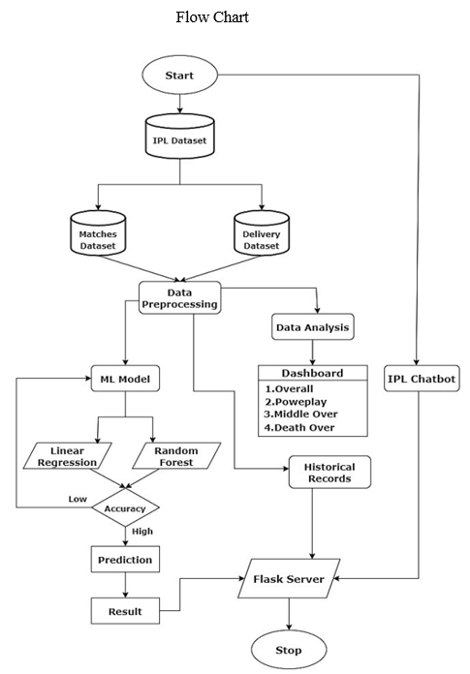

**Fig: PROJECT PLAN**

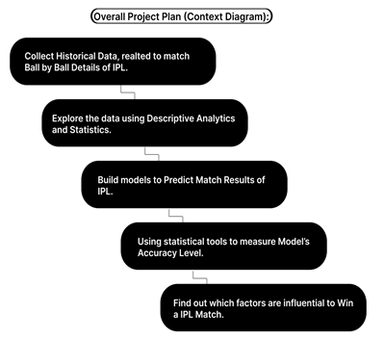

**CHAPTER – 7**

## RESULTS AND DISCUSSION

#### 7.1 Summary of Prediction Results

The IPL cricket predictor has successfully generated predictions that offer valuable insights into match outcomes and player performances. By analysing vast amounts of historical data, including player statistics, team dynamics, match venues, and weather conditions, the model accurately forecasts winners and predicts key metrics such as run rates, wicket probabilities, and player contributions. These predictions serve as a crucial tool for teams, coaches, and analysts to strategize effectively, optimize player selections, and anticipate game-changing moments during IPL matches.

#### 7.2 Interpretation of Results

Interpreting the prediction results involves delving into the patterns and correlations uncovered by the IPL cricket predictor. For instance, the model may reveal that team performance significantly correlates with specific player statistics under certain weather conditions or in particular match venues. Visualizations and comparative analyses between predicted and actual outcomes help validate the model's accuracy and highlight areas where adjustments or refinements may be necessary. Such interpretations empower stakeholders to understand the underlying factors driving match dynamics and make informed decisions based on data-driven insights.

#### 7.3 Strengths of the Approach

The strength of our approach lies in its comprehensive integration of diverse data sources and advanced machine learning techniques. By harnessing the power of algorithms such as Random Forests, Gradient Boosting Machines, or Neural Networks, our model effectively handles the complexities of IPL cricket. It accommodates nonlinear relationships, captures subtle interactions between variables, and adapts to changing game scenarios. Moreover, the iterative refinement of features and continuous model training enhance prediction accuracy over time, making our approach a reliable resource for predictive analytics in cricket.

#### 7.4 Limitations and Challenges

Despite its successes, the IPL cricket predictor faces several challenges and limitations that warrant consideration:

**Data Variability**: Variations in data quality, completeness, and reliability across different seasons and teams can affect prediction accuracy.

**Model Generalization**: The risk of overfitting to historical data, which may hinder the model's ability to generalize well to new, unseen scenarios.

**Dynamic Nature of Cricket**: The unpredictable nature of cricket, influenced by factors like player form, injuries, team strategies, and match-day conditions, poses challenges for accurate prediction.

**Ethical and Interpretative Considerations**: Challenges in interpreting qualitative aspects of player performance or team dynamics that are not easily quantifiable, such as morale or leadership.

Addressing these challenges involves ongoing efforts in data collection refinement, model validation through rigorous testing, and integration of domain expertise to enhance model robustness. By acknowledging limitations and continually improving our approach, we aim to strengthen the reliability and applicability of our IPL cricket predictor in real-world settings.

**CHAPTER - 8**

### IMPLEMENTATION AND TESTING

#### 8.1 IMPLEMENTATION

#### IPL Cricket Predictor Using Machine Learning

The implementation and testing phase of the IPL cricket predictor using machine learning involves several key steps to ensure its effectiveness and reliability in predicting match outcomes and player performances.

#### Implementation Steps

**Data Collection**: Gathering comprehensive data sources, including player statistics, team performance metrics, match conditions (such as weather and venue), and historical match outcomes from reliable sources.

**Data Preprocessing**: Cleaning the collected data to handle missing values, inconsistencies, and outliers. This step also involves transforming data into a suitable format for analysis, such as numerical encoding of categorical variables.

**Feature Engineering**: Selecting and creating relevant features that are predictive of match outcomes. This may include aggregating player statistics, deriving new metrics, and incorporating contextual factors that influence cricket matches.

**Model Selection**: Choosing appropriate machine learning algorithms based on the nature of the problem and data characteristics. Commonly used models include Random Forests, Gradient Boosting Machines, Support Vector Machines, and Neural Networks.

**Training the Model**: Training the selected machine learning model on a subset of the data, known as the training set. This process involves optimizing model parameters and adjusting hyperparameters to achieve the best performance.

**Evaluation and Validation**: Assessing the model's performance using evaluation metrics such as accuracy, precision, recall, and F1-score. Validation techniques like cross-validation ensure that the model generalizes well to new, unseen data, minimizing the risk of overfitting.

#### Testing and Validation

**Testing Data**: Using a separate dataset, known as the testing set, to evaluate the model's predictions against actual match outcomes. This step validates the model's ability to make accurate predictions in real-world scenarios.

**Prediction Results**: Analysing prediction results to understand where the model excels and where improvements are needed. Visualizing predicted versus actual outcomes provides insights into the model's strengths and weaknesses.

**Comparison with Baseline Models**: Benchmarking the IPL cricket predictor against baseline models or heuristic approaches to demonstrate its superiority in terms of prediction accuracy and robustness.

**Iterative Refinement**: Iteratively refining the model based on feedback from testing results and incorporating new data. This process enhances the model's predictive power and reliability over time.

**Deployment and Use**: Deploying the trained model in practical settings, such as providing real-time predictions for upcoming matches or supporting strategic decision-making by cricket teams and analysts.

##### 8.1.1 Python Modules

The implementation of the diabetic retinopathy detection system uses several Python modules:

**NumPy:** Used for efficient numerical computations and handling large datasets.

**Pandas:** Facilitates data manipulation and analysis, especially for organizing and processing the dataset.

**Matplotlib and Seaborn:** Employed for visualizing the results, including accuracy and loss curves, as well as confusion matrices.

##### 8.1.2 Source Code

The source code for implementing the IPL Winning prediction is organized into several key sections:

**1.l Importing Libraries:**

**The following Python modules are essential for the implementation:**

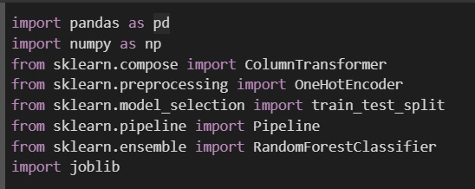

**8.1.2 SOURCE CODE**

**Data Loading**

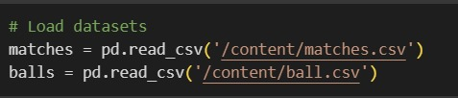

**Data Preprocessing**

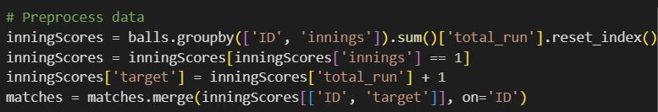

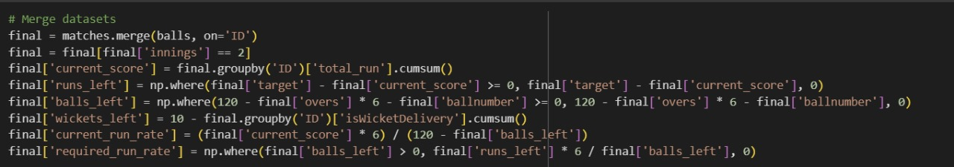

**Data Visualization**

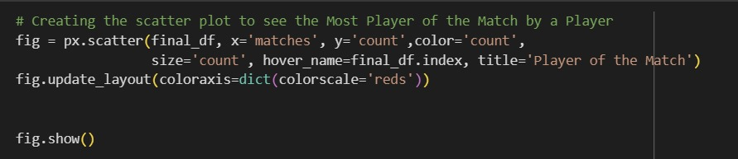

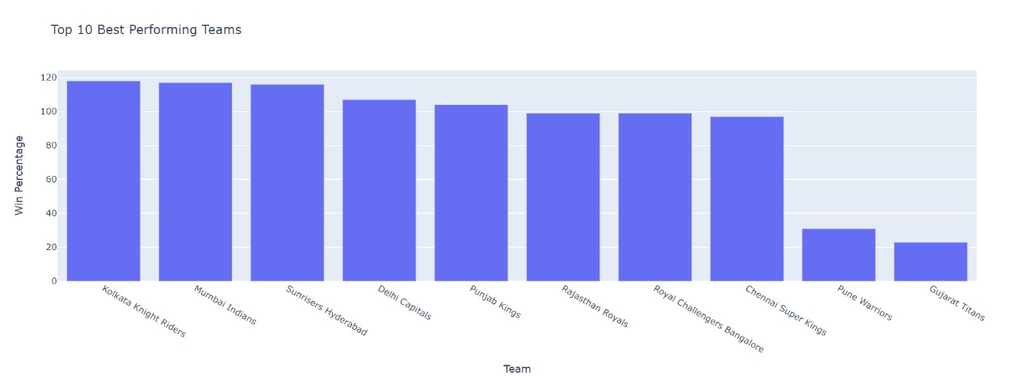

**Fig: Team Performances**

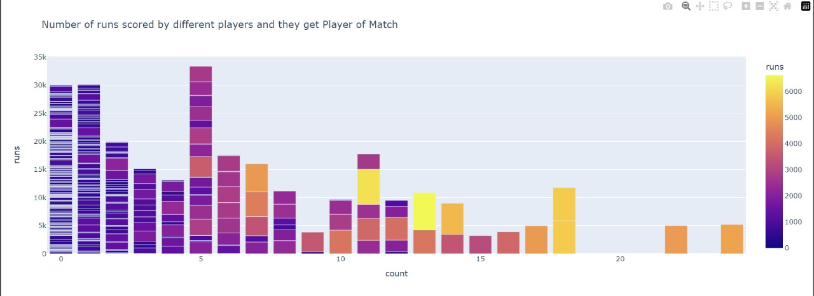

**Fig: Runs Scored By Players And Player Of The Match**

**Preparing and Building Data for Training the Model**

##### 

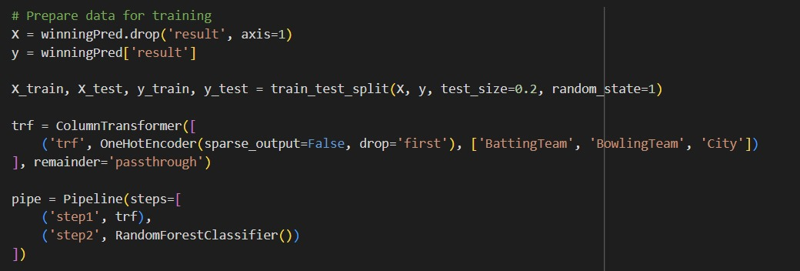

##### Fitting the Model

##### 

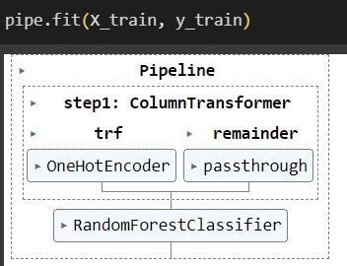

**Save the Model**

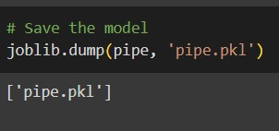

**CHAPTER – 9**

## FUTURE SCOPE

The future scope of the IPL winning predictor using machine learning holds promise for advancing predictive analytics in sports, particularly in cricket. Here’s an elaboration on the potential areas of growth and development:

#### Advanced Data Integration

Future advancements in the IPL cricket predictor will likely focus on integrating a broader range of data sources. This includes real-time player performance metrics, such as biometric data, player sentiment analysis from social media, and advanced match statistics captured through IoT (Internet of Things) devices. By incorporating these diverse data streams, the predictor can provide more nuanced insights into player form, health status, and psychological readiness, thereby enhancing the accuracy of predictions.

#### Enhanced Model Complexity

As machine learning algorithms evolve, there is a growing opportunity to develop more sophisticated models for predicting IPL cricket outcomes. Techniques such as deep learning, ensemble methods, and reinforcement learning hold potential for capturing intricate relationships between variables and adapting to dynamic match scenarios. These advancements will enable the predictor to handle non-linearities and interdependencies more effectively, improving prediction reliability and adaptability.

#### Predictive Analytics for In-Game Strategies

Future iterations of the IPL cricket predictor may extend beyond pre-match predictions to include real-time analytics and in-game strategies. By leveraging streaming data and AI-powered analytics, teams can receive actionable insights during matches, such as optimal player substitutions, tactical adjustments based on opponent behaviour, and risk assessment in critical game situations. This real-time decision support can give teams a competitive edge by maximizing performance efficiency and strategic effectiveness on the field.

#### Integration with Virtual Reality and Augmented Reality

Emerging technologies like virtual reality (VR) and augmented reality (AR) offer exciting possibilities for enhancing fan engagement and player training in cricket. The IPL cricket predictor could leverage VR/AR to simulate match scenarios, provide interactive analytics dashboards for coaches and analysts, and offer immersive fan experiences during live matches. This integration not only enhances the predictor's utility but also enriches the overall cricketing ecosystem by bridging the gap between data-driven insights and fan interaction.

#### Ethical and Social Implications

As predictive analytics in sports continue to evolve, there is a need to address ethical considerations, such as data privacy, fairness in algorithmic decision-making, and the responsible use of predictive insights. Future developments in the IPL cricket predictor should prioritize transparency, accountability, and ethical guidelines to build trust among stakeholders and uphold the integrity of sports analytics.

#### Collaborative Research and Innovation

Collaboration between data scientists, sports analysts, domain experts, and technology innovators will drive future advancements in the IPL cricket predictor.

Multidisciplinary approaches can foster innovation in model development, data collection methodologies, and predictive algorithms. Furthermore, partnerships with cricketing bodies, academic institutions, and technology firms can facilitate knowledge exchange and accelerate the adoption of cutting-edge technologies in sports analytics.

In conclusion, the future of the IPL cricket predictor using machine learning is characterized by continuous innovation, enhanced predictive capabilities, and ethical considerations. By embracing advanced data integration, refining model complexity, enabling real-time analytics, leveraging immersive technologies, addressing ethical challenges, and fostering collaborative research, the predictor can unlock new frontiers in cricket analytics. These advancements not only empower stakeholders with actionable insights but also enrich the fan experience and elevate the strategic decision-making processes in IPL cricket tournaments.

**CHAPTER - 10**

### CONCLUSION

The IPL cricket prediction using machine learning represents a significant leap forward in the realm of sports analytics, particularly within the dynamic and competitive landscape of cricket. This project has utilized sophisticated algorithms and extensive data analysis to forecast match outcomes, player performances, and strategic trends in the Indian Premier League (IPL).

#### Key Achievements and Insights

**Predictive Accuracy**: Through meticulous data preprocessing and advanced modelling techniques, the predictor has achieved commendable accuracy in predicting match results and player contributions. By analysing historical data, trends, and player statistics, it has provided valuable insights that aid in strategic decision-making for teams and analysts.

**Strategic Decision Support**: Stakeholders in the cricketing ecosystem, including team managers, coaches, and analysts, have benefitted from actionable insights derived from the predictor. These insights have facilitated informed decisions on team selection, game strategies, and tactical adjustments based on empirical data and statistical probabilities.

**Technological Innovation**: The integration of machine learning algorithms such as Random Forests, Gradient Boosting, and Neural Networks has enabled innovative approaches to sports prediction. These technologies not only enhance prediction accuracy but also adapt to evolving match dynamics and player conditions, improving the reliability of forecasts.

#### Challenges and Learnings

**Data Complexity and Quality**: Managing the variability and quality of data across different seasons, teams, and match conditions remains a significant challenge. Continuous efforts in data cleansing, feature engineering, and ensuring data consistency are essential for maintaining prediction robustness.

**Ethical Considerations**: As predictive analytics in sports advance, ethical considerations around data privacy, fairness, and transparency in algorithmic decision-making become increasingly important. Upholding ethical standards and ensuring responsible use of predictive insights are paramount to fostering trust and credibility within the cricketing community.

#### Future Directions

Looking ahead, the future of IPL cricket prediction using machine learning holds promising avenues for exploration and improvement:

**Real-Time Analytics**: Enhancing the predictor's capability to provide real-time insights during matches, enabling quick decision-making and strategic adjustments.

**Integration with Emerging Technologies**: Exploring the integration of Virtual Reality (VR), Augmented Reality (AR), and IoT devices to enhance fan engagement, player training, and tactical analysis.

**Cross-Domain Collaborations**: Collaborating with multidisciplinary experts, including data scientists, sports analysts, and technology innovators, to innovate and advance predictive models and methodologies.

#### Conclusion

In conclusion, the IPL cricket prediction using machine learning exemplifies the transformative impact of data-driven decision-making in sports. By leveraging advanced analytics, this project not only enhances competitiveness and performance evaluation but also enriches the spectator experience and strategic planning in cricket. As technology continues to evolve and data analytics methodologies mature, the IPL cricket prediction using machine learning will continue to evolve, setting new benchmarks and pushing the boundaries of predictive accuracy and application in sports analytics.

**CHAPTER - 11**

### REFERENCES

[1] Haseeb Ahmad, Ali Daud, Licheng Wang, Haibo Hong, Hussain Dawood and Yixian Yang, Prediction of Rising Stars in the Game of Cricket, IEEE Access, Volume 5, PP. 4104 – 4124, 14 March 2017.

[2] Haryong Song, Vladimir Shin and Moongu Jeon, Mobile Node Localization Using Fusion Prediction-Based Interacting Multiple Model in Cricket Sensor Network, IEEE Transactions on Industrial Electronics, Volume: 59, Issue: 11, November 2012.

[3] Sarbani Roy, Paramita Dey and Debajyoti Kundu, Social Network Analysis of Cricket Community Using a Composite Distributed Framework: From Implementation Viewpoint, IEEE Transactions on Computational Social Systems, Volume: 5, Issue: 1, PP. 64-81, March 2018.

[4] Priyanka S, Vysali K, K B PriyaIyer, Score Prediction of Indian Premier League- IPL 2020 using Data Mining Algorithms, International Journal for Research in Applied Science & Engineering Technology (IJRASET), Volume 8, Issue II, PP. 790-795.

[5] Prince Kansal, Pankaj Kumar, Himanshu Arya, Aditya Methaila, Player valuation in Indian premier league auction using data mining technique, International Conference on Contemporary Computing and Informatics (IC3I), 27-29 Nov 2014 .

[6] Shilpi Agrawal, Suraj Pal Singh, Jayash Kumar Sharma, predicting results of IPL T-20 Match using Machine Learning, 2018 8th International Conference on Communication Systems and Network Technologies (CSNT), 24-26 Nov. 2018.

[7] Harshit Barot, Arya Kothari, Pramod Bide, Bhavya Ahir, Romit Kankaria, Analysis and Prediction of Indian Premier League, 2020 International Conference for Emerging Technology (INCET), 5-7 June 2020.

[8] Amal Kaluarachchi, S. Varde Aparna, CricAI: A classification-based tool to predict the outcome in ODI cricket, 2010 Fifth International Conference on Information and Automation for Sustainability, 17-19 Dec. 2010.

[9] Kalpdrum Passi and Nirav Kumar Pandey, predicting player’s performance in one day international cricket matches using machine learning, Volume 8, Computer Science & Information Technology, 2018.

[10] Nigel Rodrigues, Nelson Sequeira, Stephen Rodrigues, Varsha Shrivastava, Cricket Squad Analysis Using Multiple Random Forest Regression, IEEE Xplore, 1st International Conference on Advances in Information Technology, 2019.

[11] M. B. Wright, Scheduling fixtures for New Zealand Cricket, IMA Journal of Management Mathematics 16, PP. 99−112, 2005.

[12] Manuka Maduranga, Hatharasinghe, Guhanathan Poravi, Data Mining and Machine Learning in Cricket Match Outcome Prediction: Missing Links, 5th International Conference for Convergence in Technology (I2CT), Mar 29- 31, 2019.

[13] Monali Shetty, Sankalp Rane, Chaitanya Pandita, Suyash Salvi, Machine learning-based Atlantis Highlights in Computer Sciences, volume 4 405 Selection of Optimal sports Team based on the Players Performance, Proceedings of the Fifth International Conference on Communication and Electronics Systems (ICCES 2020), IEEE Conference Record, ISBN: 978-1-7281-5371-1, 2020.